Hotel Transylvania

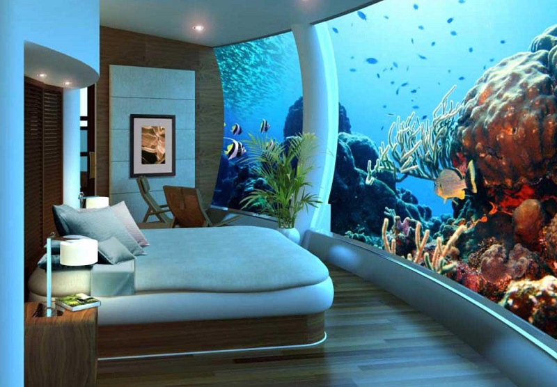

AMANULLAH

Table of Contents

Table of Contents i

Revision History ii

1. Introduction 1

1.1 Purpose 1

1.2 Document Conventions 1

1.4 Product Scope 1

3. System Features 4

3.1 System Feature 1 4

3.2 System Feature 2 (and so on) 5

5. Other Nonfunctional Requirements 5

5.1 Performance Requirements 5

5.2 Safety Requirements 6

5.3 Security Requirements 6

5.4 Software Quality Attributes 6

5.5 Business Rules 6

6. Other Requirements 7

7. Use cases 7

7.1 List of Use cases 7

7.2 Use Case Diagram 8

Appendix A: Glossary 10

Appendix B: Analysis Models 10

Appendix C: To Be Determined List 10

**1.INTRODUCTION**

This hotel management system is developed for hotels those are using a manual system to handle hotel processes. There are three main users in hotel management system, administrator, Manager and Receptionist. Administrator can maintain daily updates in the hotel records. This system will automate the major operations of the hotel. Administrator can access to all system functionalities without any restrictions. Administrator is must be an authorized user. He can further change the password. There is the facility for password recovery, logout etc. Manager can access to all system functionalities with limited restrictions. Receptionist can only access to the Reservation Management section . The Reservation System is to keep track in room and hall reservation and check availability.

 Using this system user can check which room is reserved and which room is available. He can check **food service** and **hotel’s online shopping service , Book a car for tour**  from this module. Using this system you can manage check in and check out process easily. At check in, you can easily check the **availability of rooms** in the hotel. And at check out you can **easily generate** the **total bill**.

**1.1 Purpose**

#### The purpose of Hotel Management is to provide quality and standard services to the customers that stay in a Hotel . Reduce time spent on administrative tasks.

#### You can increase your brand presence online. Management software that is integrated with your[website builder](https://www.siteminder.com/hotel-website-design/) will allow you to accept direct online bookings and develop a user-friendly website.

## **1.2 Document Conventions**

The document is prepared using Microsoft Word 2013 and has used the font type 'Calibri. It has used the bold property to set the headings of the document. Standard IEEE template is the template used to organize the appearance of the document and its flow.

## **1.3 Product Scope**

The aim of this **project** is to design a **hotel management system** for running a **hotel** business. The **system** should be as flexible as possible so that it can be used for different **hotels.**

There are hundreds of hotel booking systems out there. Try to think from a business perspective: Which innovative features could you offer in order to distinguish your system from existing ones? We welcome and encourage creative solutions. At the same time, the core functionality of the hotel business has to be there! We do not know or cannot know all the solutions of this project, because there is not a single solution, but several. The benefits of a solution depend on what you want to achieve with your system.

**3. Major Features**

|  |  |
| --- | --- |
| FE-1: | Room Detail Functions |
| FE-2: | Online Check-in and check-out Detail Functions |
| FE-3: | Room assigning related to customer’s need. |
| FE-4: | Customer account detail / customer profile |
| FE-5: | Online Bill Details |
| FE-6: | Advance online bookings. |
| FE-7: | Online Feedbacks |
| FE-8: | Online Food Services |
| FE-9: | online shopping services |
| FE-10 | Online Book a vehicle |

**3.1 Room Detail Functions**

It tells the room details, whether the specific room is available or not ,also tells the room’s luxury level ,like single bed room or double bed room ,apartment type etc.

**3.2 Online Check-in and check-out Detail Functions**

In this the Hotel Transylvania gives user to check-in and check-out online .like while checking –in it automatically charged the reservation price online with the help of user bank account no . similarly same thing happen while checking-out .

**3.3 Room assigning related to customer’s need.**

In this the feature the Hotel Transylania gives customers a special offer that is assigning them the room according to their needs like **under water room** (fully luxury) , apartment type room etc

**3.4 Customer Account Detail / Customer Profile**

While checking-in there is generate account of that customer where he\she can see his /her profile details ,like order details(shopping , food services) in services menu , bill details , book a vehicle etc.

**3.5 Online Bill Details**

There is online feature that generate the overall (all services ) bill of a particular customer

**3.6 Advance Online Bookings**

**3.7 Online Feedbacks**

**User give the feedback about hospitality, environment etc.**

**3.**8 Food Services

If there are multiple point-of-sale terminals in a hotel, this function is indispensable to handle transactions. It automates transactions and keeps financial data in one place. Most hotels have some kind of restaurant on the premises, not to mention properties with gyms and spas. With a PMS, hoteliers can include additional costs or discounts to the final bill for each customer. Additional costs may include:

* Food and beverage services (restaurants, cafes, breakfasts)
* In-room services, mini-bar items, TV, or Wi-Fi.

**3.9 Online Shopping Services**

If there are multiple point-of-sale terminals in a hotel, this function is indispensable to handle transactions. It automates transactions and keeps financial data in one place. Most hotels have some kind of restaurant on the premises, not to mention properties with gyms and spas. With a PMS, hoteliers can include additional costs or discounts to the final bill for each customer. Additional costs may include:

* Food and beverage services (restaurants, cafes, breakfasts)
* In-room services, mini-bar items, TV, or Wi-Fi.

3.10 Online Book a vehicle

Hotel Transylvania also provide you online feature to book a vehicle for tour or to go to anywhere where you do you want , like hill Stations , Historical places etc.

# 4.System Features

This template illustrates organizing the functional requirements for the product by system features, the major services provided by the product

**4.1 Nonfunctional Requirements**

**Performance Requirements**

|  |  |
| --- | --- |
| PE-1: | The system shall accommodate 400 users during the peak usage time window of 8:00 A.M. to 10:00 A.M. local time, with an estimated average session duration of 8 minutes. |
| PE-2: | All Web pages generated by the system shall be fully downloadable in no more than 10 seconds over a 40 KBps modem connection. |
| PE-3: | Responses to queries shall take no longer than 7 seconds to load onto the screen after the user submits the query. |
| PE-4: | The system shall display confirmation messages to users within 4 seconds after the user submits information to the system. |

**Performance:** During past several decades, the records are supposed to be manually handled for all activities. The manual handling of the record is time consuming and highly prone to error.

To improve the performance of the Hotel Management System, the computerized system is to be undertaken. This project is fully computerized and user friendly even that any of the members can see the report and status of the company.

**Efficiency:** The basic need of this website is efficiency. The website should be efficient so that whenever a new user submits his/her details the website is updated automatically. This record will be useful for other users instantly.

**Control:** The complete control of the project is under the hands of authorized person who has the password to access this project and illegal access is not supposed to deal with. All the control is under the administrator and the other members have the rights to just see the records not to change any transaction or entry.

**Security:** Security is the main criteria for the proposed system. Since illegal access may corrupt the database. So security has to be given in this project.